Question:
Find the interpolated value using Newton forward differences interpolation using Python.
Aim:
Write a Python program to demonstrate to find the interpolated value using Newton forward differences interpolation.
Program:
from math import factorial

# Build forward difference table
def forward_difference(y):
n = len(y)
diff_table = [y]
for i in range(1, n):
col = []
for j in range(n - i):
col.append(diff_table[i - 1][j + 1] - diff_table[i - 1][j])
diff_table.append(col)
return diff_table

# Newton Forward Interpolation
def newton_forward(x, y, value):
n = len(x)
h = x[1] - x[0] # step size (assumes equally spaced x values)
p = (value - x[0]) / h

diff_table = forward_difference(y)

result = y[0]
term = 1
for i in range(1, n):
term *= (p - (i - 1))
result += (term * diff_table[i][0]) / factorial(i)

return result, diff_table
n = int(input("Enter number of data points: "))

x = []
y = []

print("Enter x values (equally spaced):")
for i in range(n):
x.append(float(input(f"x[{i}] = ")))

print("Enter y values (corresponding to f(x), type 'null' if unknown):")
for i in range(n):
val = input(f"y[{i}] = ")
if val.lower() == "null":
y.append(None) # store as None
else:
y.append(float(val))

# Remove pairs where y is None
x_clean = []
y_clean = []
for xi, yi in zip(x, y):
if yi is not None:
x_clean.append(xi)
y_clean.append(yi)

if len(x_clean) < 2:
print("\nError: Not enough known y values for interpolation.")
else:
x_val = float(input("Enter the value of x to interpolate: "))

# Perform interpolation
result, table = newton_forward(x_clean, y_clean, x_val)

# Display Results
print("\nForward Difference Table:")
for i in range(len(table)):
print(f"Δ^{i}y:", table[i])

print(f"\nInterpolated value at x = {x_val} is {result}")
Result:
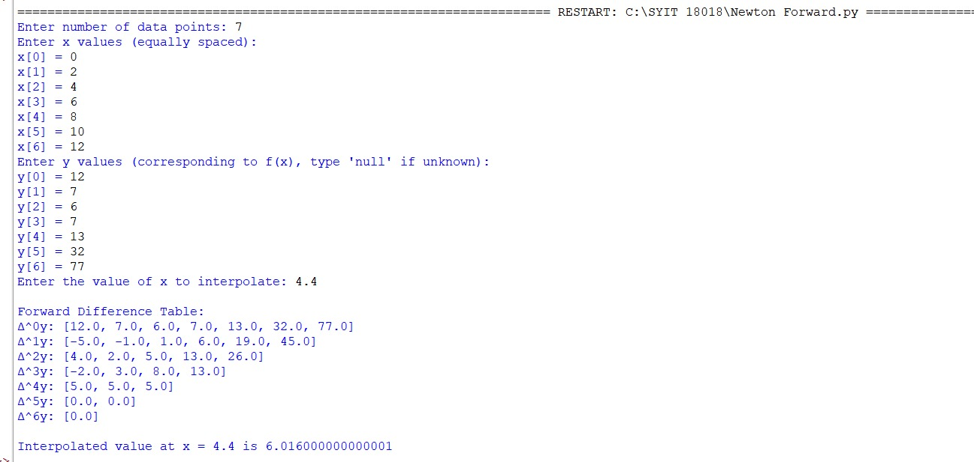

Conclusion:
The above Python program has been executed successfully.

